Game Design Document

Fill up the following document

1. Write the title of your project.

Flappy bird

1. What is the goal of the game?

To try to get the highest score

1. Write a brief story of your game.

A bird was getting late for school so he decided to take a short cut. He did not know that the short cut had many obstacles. He has to try to get through them

1. Which are the playing characters of this game?

* Playing characters are the ones who respond to the user based on the input from the user.
* Cars, monkeys, dinos, wizards, etc., are the playing characters in the game.

|  |  |  |
| --- | --- | --- |
| Number | Character Name | What can this character do? |
| 1 | Flappy bird | fly |
| 2 |  |  |
| 3 |  |  |
| 4 |  |  |
| 5 |  |  |
| 6 |  |  |
| 7 |  |  |
| 8 |  |  |

1. Which are the Non-Playing Characters of this game?

* Non-Playing characters are the ones that don't have an action or behavior when the user interacts with the game.
* Hurdles, stones, bananas, coins, etc., are non-playing characters in the game.

|  |  |  |
| --- | --- | --- |
| Number | Character Name | What can this character do? |
| 1 |  |  |
| 2 |  |  |
| 3 |  |  |
| 4 |  |  |
| 5 |  |  |
| 6 |  |  |
| 7 |  |  |
| 8 |  |  |

Draw your imagination of this game. What does this game look like?

* Draw the game either on your computer or on paper.
* Add images of the game scenes to show each of the playing and non-playing characters at least once.

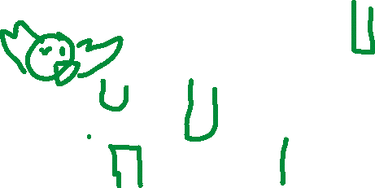

How do you plan to make your game engaging?

I plan on make it very hard and challenging